UNITED STATES

SECURITIES AND EXCHANGE COMMISSION
Washington, D.C. 20549

Form 6-K

REPORT OF FOREIGN PRIVATE ISSUER PURSUANT TO RULE 13a-16 OR 15d-16

UNDER THE SECURITIES EXCHANGE ACT OF 1934

For the month of September, 2024.

Commission File Number: 001-40673

Cybin Inc.

(Exact Name of Registrant as Specified in Charter)

100 King Street West, Suite 5600, Toronto, Ontario, M5X 1C9

(Address of principal executive offices)

Indicate by check mark whether the registrant files or will file annual reports under cover Form 20-F or Form 40-F.

Form 20-F □ Form 40-F ⊠

INCORPORATION BY REFERENCE

Exhibits 99.1, 99.2 and 99.3 of this Form 6-K are hereby incorporated by reference into the Registration Statement on Form F-10 (File No. 333-272706) and the Registration Statement on Form F-10 (File No. 333-276333) of the Company, as amended or supplemented.

SIGNATURE

Pursuant to the requirements of the Securities Exchange Act of 1934, the registrant has duly caused this report to be signed on its behalf by the undersigned, thereunto duly authorized.

 |  | CYBIN INC.
 |  | (Registrant)
Date: | September 19, 2024 | By: | /s/ Doug Drysdale
 |  | Name: | Doug Drysdale
 |  | Title: | Chief Executive Officer

EXHIBIT INDEX

99.1 | Material Change Report dated on September 19, 2024
99.2 | Cybin Share Consolidation Press Release
99.3 | Certificate and Articles of Amendment
99.4 | Letter of Transmittal

FORM 51-102F3

MATERIAL CHANGE REPORT

Item 1 Name and Address of Company

Cybin Inc. (the “Company”)

100 King Street West, Suite 5600

Toronto, Ontario

M5X 1C9

Item 2 Date of Material Change

September 19, 2024

Item 3 News Release

A press release disclosing the material change was disseminated on September 19, 2024 through BusinessWire.

Item 4 Summary of Material Change

On September 19, 2024, the Company announced that it had filed articles of amendment to consolidate the Company’s issued and outstanding common shares (the “Common Shares”) on the basis one new Common Share for every 38 existing Common Shares (the “Consolidation”).

Item 5 Full Description of Material Change

The Consolidation is effective as of September 19, 2024. As a result of the Consolidation, the 759,692,495 Common Shares issued and outstanding prior to the Consolidation have been reduced to approximately 19,991,907 Common Shares. Each shareholder’s percentage ownership in the Company and proportional voting power remains unchanged after the Consolidation, except for minor changes and adjustments resulting from the treatment of any fractional Common Shares.

The Company did not issue fractional post-Consolidation Common Shares. Where the Consolidation would otherwise result in a shareholder being entitled to a fractional Common Share, the number of post-Consolidation Common Shares issued to such shareholder was rounded to the nearest whole number of post-Consolidation Common Shares.

The board of directors of the Company approved the consolidation ratio for the Consolidation on August 27, 2024. Shareholder approval of the Consolidation was obtained at the Company’s annual and special meeting of shareholders held on August 27, 2024.

In connection with the Consolidation, the Company will send letters of transmittal to registered holders of its Common Shares for use in transmitting their existing share certificates (“Existing Certificates”) to the Company’s registrar and transfer agent, Odyssey Trust Company, in exchange for new certificates (“New Certificates”) representing the number of post-Consolidation Common Shares to which such

2

shareholder is entitled as a result of the Consolidation. No delivery of a New Certificate to a shareholder will be made until the shareholder has surrendered its Existing Certificates. Until surrendered, each Existing Certificate shall be deemed for all purposes to represent the number of post-Consolidation Common Shares to which the holder is entitled as a result of the Consolidation.

The exercise price and number of Common Shares issuable upon exercise of the Company’s outstanding Common Share purchase warrants and options have been adjusted in accordance with the Consolidation.

Item 6 Reliance on subsection 7.1(2) of National Instrument 51-102

Confidentiality is not requested.

Item 7 Omitted Information

No information has been omitted in respect of the material change.

Item 8 Executive Officer

Further information regarding the matters described in this report may be obtained from Douglas Drysdale, Chief Executive Officer of the Company, who is knowledgeable about the details of the material change and may be contacted at 1-866-292-4601.

Item 9 Date of Report

September 19, 2024

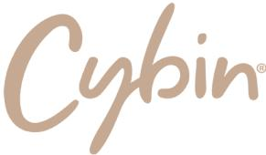

Cybin Announces Completion of Previously Announced Share Consolidation

TORONTO, CANADA – September 19, 2024 – Cybin Inc. (NYSE American: CYBN) (Cboe CA:CYBN) (“Cybin” or the “Company”), a clinical-stage breakthrough neuropsychiatry company committed to revolutionizing mental healthcare by developing new and innovative next-generation treatment options, is pleased to announce that it has filed articles of amendment to consolidate the Company’s issued and outstanding common shares (the “Common Shares”) on the basis of one new Common Share for every 38 existing Common Shares (the “Consolidation”). The Consolidation is effective immediately and trading of the Common Shares reflecting the Consolidation will commence at the opening of trading today.

As a result of the Consolidation, the 759,692,495 Common Shares issued and outstanding prior to the Consolidation have been reduced to approximately 19,991,907 Common Shares, subject to adjustment for treatment of fractional Common Shares. Each shareholder’s percentage ownership in the Company and proportional voting power remains unchanged after the Consolidation, except for minor changes and adjustments resulting from the treatment of any fractional Common Shares.

The exercise price and number of Common Shares issuable upon exercise of the Company’s outstanding Common Share purchase warrants and options have been adjusted in accordance with the Consolidation.

About Cybin

Cybin is a clinical-stage breakthrough neuropsychiatry company on a mission to create safe and effective next-generation therapeutics to address the large unmet need for new and innovative treatment options for people who suffer from mental health conditions.

Cybin’s goal of revolutionizing mental healthcare is supported by a network of world-class partners and internationally recognized scientists aimed at progressing proprietary drug discovery platforms, innovative drug delivery systems, novel formulation approaches and treatment regimens. Cybin is currently developing CYB003, a proprietary deuterated psilocin program for the treatment of major depressive disorder and CYB004, a proprietary deuterated dimethyltryptamine program for generalized anxiety disorder and has a research pipeline of investigational psychedelic-based compounds.

Headquartered in Canada and founded in 2019, Cybin is operational in Canada, the United States, the United Kingdom, the Netherlands and Ireland. For Company updates and to learn more about Cybin, visit www.cybin.com or follow the Company on X, LinkedIn, YouTube and Instagram.

Cautionary Notes and Forward-Looking Statements

Certain statements in this news release relating to the Company are forward-looking statements and are prospective in nature. Forward-looking statements are not based on historical facts, but rather on current expectations and projections about future events and are therefore subject to risks and uncertainties which could cause actual results to differ materially from the future results expressed or implied by the forward-looking statements. These statements generally can be identified by the use of forward-looking words such as “may”, “should”, “could”, “intend”, “estimate”, “plan”, “anticipate”, “expect”, “believe” or “continue”, or the negative thereof or similar variations. Forward-looking statements in this news release include statements regarding the Company’s plans to engineer proprietary drug discovery platforms, innovative drug delivery systems, novel formulation approaches and treatment regimens for mental health conditions.

These forward-looking statements are based on reasonable assumptions and estimates of management of the Company at the time such statements were made. Actual future results may differ materially as forward-looking statements involve known and unknown risks, uncertainties, and other factors which may cause the actual results, performance, or achievements of the Company to materially differ from any future results, performance, or achievements expressed or implied by such forward-looking statements. Such factors, among other things, include: fluctuations in general macroeconomic conditions; fluctuations in securities markets; expectations regarding the size of the psychedelics market; the ability of the Company to successfully achieve its business objectives; plans for growth; political, social and environmental uncertainties; employee relations; the presence of laws and regulations that may impose restrictions in the markets where the Company operates; implications of disease outbreaks on the Company's operations; and the risk factors set out in each of the Company's management's discussion and analysis for the three months ended June 30, 2024 and the Company’s annual information form for the year ended March 31, 2024, which are available under the Company's profile on www.sedarplus.ca and with the U.S. Securities and Exchange Commission on EDGAR at www.sec.gov. Although the forward-looking statements contained in this news release are based upon what management of the Company believes, or believed at the time, to be reasonable assumptions, the Company cannot assure shareholders that actual results will be consistent with such forward-looking statements, as there may be other factors that cause results not to be as anticipated, estimated or intended. Readers should not place undue reliance on the forward-looking statements and information contained in this news release. The Company assumes no obligation to update the forward-looking statements of beliefs, opinions, projections, or other factors, should they change, except as required by law.

Cybin makes no medical, treatment or health benefit claims about Cybin’s proposed products. The U.S. Food and Drug Administration, Health Canada or other similar regulatory authorities have not evaluated claims regarding psilocin, psilocybin, psychedelic tryptamine, tryptamine derivatives or other psychedelic compounds. The efficacy of such products has not been confirmed by approved research. There is no assurance that the use of psilocin, psilocybin, psychedelic tryptamine, tryptamine derivatives or other psychedelic compounds can diagnose, treat, cure or prevent any disease or condition. Rigorous scientific research and clinical trials are needed. If Cybin cannot obtain the approvals or research necessary to commercialize its business, it may have a material adverse effect on Cybin’s performance and operations.

Neither the Cboe Canada, nor the NYSE American LLC stock exchange have approved or disapproved the contents of this news release and are not responsible for the adequacy and accuracy of the contents herein.

Investor & Media Contact:

Gabriel Fahel

Chief Legal Officer

Cybin Inc.

1-866-292-4601

irteam@cybin.com – or – media@cybin.com

61689835.2

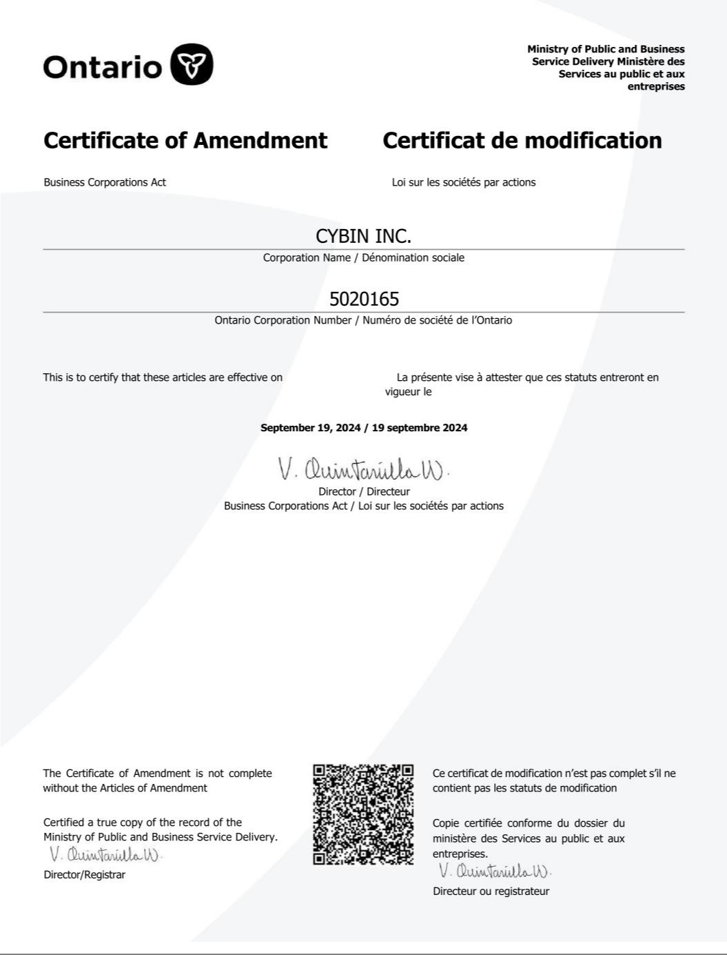

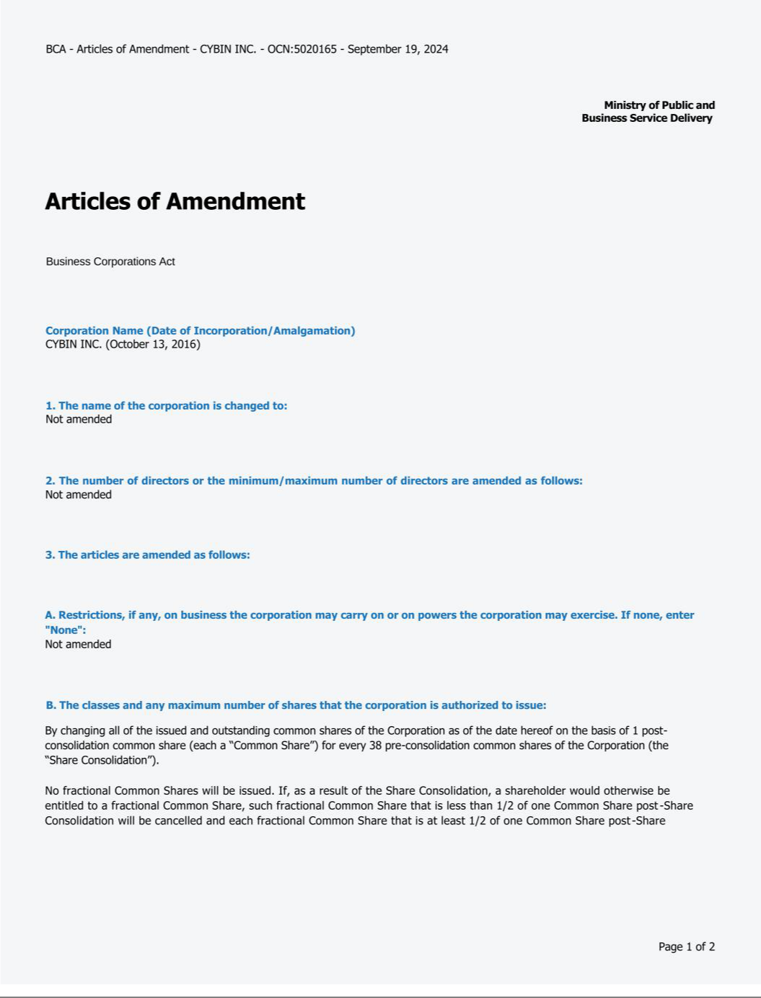

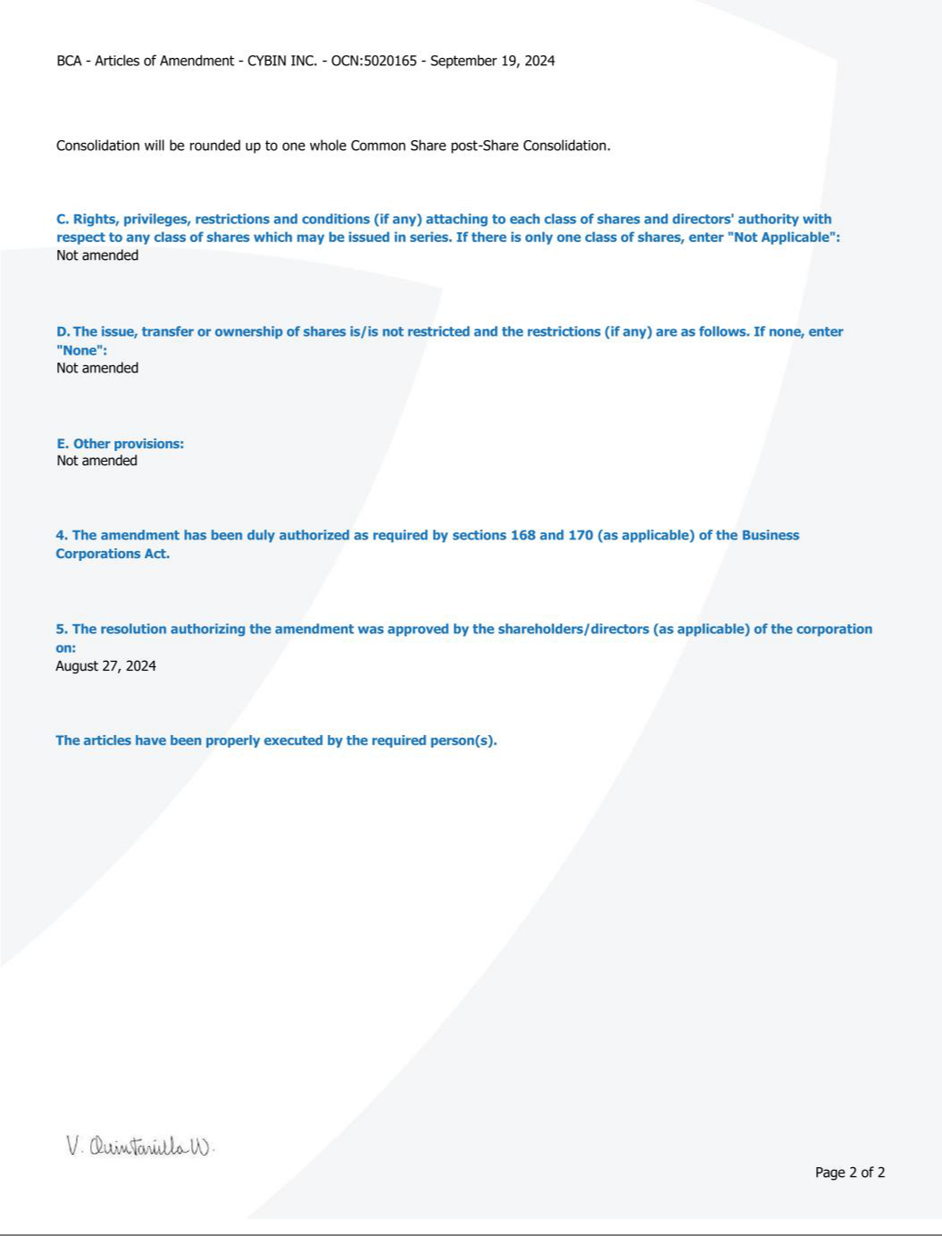

CYBIN INC

LETTER OF TRANSMITTAL

TO: ODYSSEY TRUST COMPANY

The undersigned hereby represents and warrants that the undersigned is the owner of the number of common shares (“common shares”) of Cybin Inc. (“CYBN”) which shares are represented by the shares described below and delivered herewith and the undersigned has good title to the shares represented below, free and clear of all liens, charges and encumbrances, and has full power and authority to herewith deposit such shares.

Certificate Number or DRS Account Number | Number of Shares | Registered in the Name of

The above-listed shares are hereby surrendered in exchange for consolidated common shares of CYBN on the basis of thirty eight (38) old common shares of CYBN for one (1) post-consolidated share of CYBN. CYBN will not issue any fractional common shares as a result of the consolidation. If, as a result of the consolidation, the shareholder would otherwise be entitled to a fractional post-consolidation common share, such fractional post-consolidation common share that is less than 1/2 of one post-consolidation common share will be cancelled and each fractional post-consolidation common share that is at least 1/2 of one post-consolidation common share will be rounded up to one whole post-consolidation common share.

The undersigned authorizes and directs Odyssey Trust Company to issue a Direct Registration System (“DRS”) statement for the consolidated common shares to which the undersigned is entitled as indicated below and to e-mail such advice to the e-mail address indicated below or, if no instructions are given, in the name and to the address if any, of the undersigned as it appears on the share register maintained by Odyssey Trust Company. In the event that a DRS statement is not available, a CYBN stock certificate will be issued and mailed to the address indicated below.


To be registered in the name of (please print)

Name of authorized representative (if applicable)

Address

City Province Postal Code

Telephone | E-mail (*) | SIN / TIN

* By providing an email address, the undersigned consents to electronic delivery by the Transfer Agent.

- Please issue a physical share certificate instead of a DRS statement

Date: ___________________________ __________________________________________

Signature of Shareholder(s) or Authorized Representative

(See additional requirement for authorized representative under instruction 1d)

SIGNATURE GUARANTEE

(if required under Instruction 1c):

Authorized Signature

Name of Guarantor

Address / Telephone

INSTRUCTIONS FOR COMPLETING THE LETTER OF TRANSMITTAL

- Use of Letter of Transmittal

- Each shareholder holding share certificates or DRS of CYBN must send or deliver this Letter of Transmittal duly completed and signed together with the share certificates or DRS described herein to Odyssey Trust Company (“Odyssey”) at the office listed below. The method of delivery to Odyssey is at the option and risk of the shareholder, but if mail is used, registered mail is recommended.
- Shares registered in the name of the person by whom (or on whose behalf) the Letter of Transmittal is signed need not be endorsed or accompanied by any share transfer power of attorney.
- Shares not registered in the name of the person by whom (or on whose behalf) the Letter of Transmittal is signed must be endorsed by the registered holder thereof or deposited together with a share transfer power of attorney properly completed by the registered holder. Such signature must be guaranteed by an Eligible Institution or in some other manner satisfactory to Odyssey. An Eligible Institution means a Canadian schedule 1 chartered bank, a member of the Securities Transfer Agent Medallion Program (STAMP), a member of the Stock Exchanges Medallion Program (SEMP) or a member of the New York Stock Exchange Inc. Medallion Signature Program (MSP). Members of these programs are usually members of a recognized stock exchange in Canada and the United States, members of the Investment Industry Regulatory Organization of Canada, members of the Financial Industry Regulatory Authority or banks and trust companies in the United States. A signature guarantee will also be accepted from a Canadian Schedule 1 chartered bank that is not participating in a Medallion Signature Guarantee Program and makes available its list of authorized signing officers to the Transfer Agent. Currently, signature guarantees are accepted from Bank of Nova Scotia, Royal Bank of Canada and TD Bank.

- Where the Letter of Transmittal is executed on behalf of a corporation, partnership, association or by an agent, executor, administrator, trustee, guardian or any person acting in an authorized representative capacity, the Letter of Transmittal must be accompanied by satisfactory evidence of the representative’s authority to sign and dated within the last 6 months. Examples include extracts from the following documents: Corporate Resolution, LLC Agreement, Corporate Registry, Partnership Agreement or Trust Agreement.
- CYBN reserves the right if it so elects in its absolute discretion to instruct Odyssey to waive any defect or irregularity contained in any Letter of Transmittal received by it.

- Lost Share Certificates

If a share certificate has been lost or destroyed, the Letter of Transmittal must be completed as fully as possible and forwarded to Odyssey together with a letter stating the loss. Odyssey will respond with the replacement requirements, which must be properly completed and returned prior to effecting the exchange.

- Miscellaneous

Additional copies of the Letter of Transmittal may be obtained from Odyssey at the office listed below. Any questions should be directed Odyssey by e-mail to corp.actions@odysseytrust.com. Enclose all certificates in the envelope provided and send it with the completed form to Odyssey.

By Mail: Trader’s Bank Building

Hand or Courier 702 – 67 Yonge St

Toronto, ON M5E 1J8

Attn: Corporate Actions

Privacy Notice: At Odyssey Trust Company, we take your privacy seriously. When providing services to you, we receive non-public, personal information about you. We receive this information through transactions we perform for you or an issuer in which you hold securities, from enrolment forms and through other communications with you. We may also receive information about you by virtue of your transactions with affiliates of Odyssey Trust Company or other parties. This information may include your name, social insurance number, securities ownership information and other financial information. With respect to both current and former customers, Odyssey Trust Company does not share non-public personal information with any non-affiliated third party except as necessary to process a transaction, service your account or as permitted by law. Our affiliates and outside service providers with whom we share information are legally bound not to disclose the information in any manner, unless permitted by law or other governmental process. We strive to restrict access to your personal information to those employees who need to know the information to provide our services to you, and we maintain physical, electronic and procedural safeguards to protect your personal information. Odyssey Trust Company realizes that you entrust us with confidential personal and financial information and we take that trust very seriously. By providing your personal information to us and signing this form, we will assume, unless we hear from you to the contrary, that you have consented and are consenting to this use and disclosure. A complete copy of our Privacy Code may be accessed at www.odysseytrust.com, or you may request a copy in writing Attn: Chief Privacy Officer, Odyssey Trust Company at 350 – 409 Granville St, Vancouver, BC, V6C 1T2.

